Hare Krishna Hare Krishna Krishna Krishna Hare Hare | Hare Rama Hare Rama Rama Rama Hare Hare

BIO-DATA

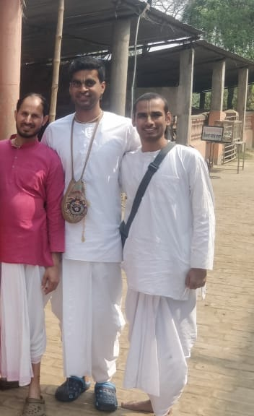**Personal details**

Name: Dr. Surendra Verma (PhD)

Date of Birth: 25-01-1993

Height: 165cm or 5’4’’

Caste: SC, Kori (Mahawar)

Color: Fair

Languages: English, Hindi

Hobbies: Cooking, Reading, Learning new things, Organizing Yatras, Helping in Management

Current Address: Toronto, Canada

**Family details**

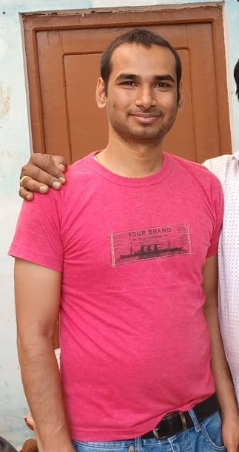Father: Suraj Ram (Income Tax officer, Gwalior)

Mother: Ram Kumari (Home Maker)

Eider Sister: Archana Arya Verma

(B.Sc and B.Ed, Married)

Eider Brother: Chandra Shekhar Arya

(B.E, Married)

Permanent Address: 1153, Babulal Ka Bagicha,

Nagaria colony, Khusipura, Jhansi (UP)

Native Place: Village Bansar, Post Bijna (Jhansi)

Father’ Gotra: Kargainya

Mother’s Gotra: Garouthiya

**Education**

Dual (B.Tech + M.Tech) and Ph.D. in Aerospace Engineering,

IIT Kharagpur, West-Bengal, India (July 10 – Dec 21)

**Work experience**

Assistant Professor for one semester contract in Punjab Engineering College, Chandigarh (July 22 – 31 Nov 22)

Post- Doctoral research fellow in Mechanical Engineering, Ryerson University, Toronto, Canada (1 Dec - Present)

**Spiritual details**

Connected to ISKCON since 2014.

My father and mother, and brother and sister-in-law are also connected to ISKCON Jhansi and doing regularly chanting.

Mentor: HG Sarojmukh Madhav Pr Ji (Jia Sarai, New Delhi)

Number of rounds: 16

Services: Chanting, Prasad cooking, Prasad offering, Reading Prabhupada’s books, Helping in management and Yatras

**Looking for**

Simple person having spiritual goal who can support me and my family. Having deep faith in Indian culture and family values. A firm believer in the joint family system.

**Contact details:**

+91 7719718193 (Abha), +91 6266739918 (Suraj Ram, Father)

+91 8436929997 (Surendra)